Conjoint Analysis Report

Marketing Analytics

MAR6936

Prof. Sajeev Varki

By:

Pranay Rao Allampalli

Anuradha Jain

Tai Nguyen

Priyanka Sariya

**INTRODUCTION**

The purpose we chose this product is that besides being one of the essential commodities for students and everyday use, there are so many upcoming selling events such as Black Friday, Cyber Monday, so on and so forth. It leads to several laptop retailers like Newegg, BHphoto, Amazon & Adorama to struggle to find the best-selling products to attract consumers. In this project, we aim to help these retailers to discover the suited products which will enable them not only to gain more consumers but also to improve their market share and hence increase the profit in the long run.

Choices among the Laptops are very confusing, and no one laptop has all the features/configurations that would satisfy customer’s needs. Our team listed down all the features that a consumer would be interested in when buying a computer. The attributes relevant to the well-suited laptops are price, RAM, HDD memory, Central Processing Unit (CPU or processor for short), weight, screen size, operating system, brand, color, touch screen, and the list goes on and on. This list was endless, so we decided to ask customers which five features from this list were the most important for them. We received the below responses from over 30 people we collected data from.

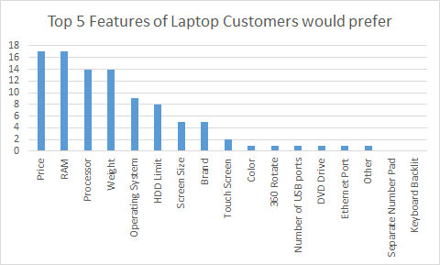

Fig. 1 Graph of top 5 Laptop Features preferred by the customer based on the survey

While talking to the customers, we also asked them about the levels they think would be appropriate for these attributes. Based on their responses and discussion within our team, we came up with the respective levels. So, the five most important features: Price, RAM, Processor, Weight, and Operating system, along with their levels, are presented below.

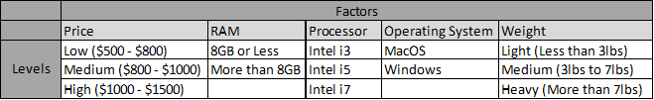

Fig. 2 Top five Laptop Features Preferred by Customer with their levels

The five features and their levels as summed up in the above table generate a total of 108 profiles (3*2*3*2*3)

**DESIGN**

We then reduced the 108 profiles to a smaller number for our customer survey so that it is easy to collect study on and easy to interpret the results. For this, we used the XLSTAT option of ‘Design for Conjoint Analysis.’ This design generated ten profiles from all the selected factors and levels. We had put some prohibited profiles criteria when making the selections as some combinations would not make much sense and were not realistic, as shown below.

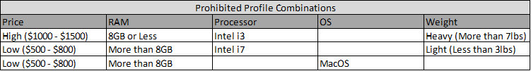

Fig. 3 Prohibited Profiles

The XLSTAT design tool generated below 10 profiles:

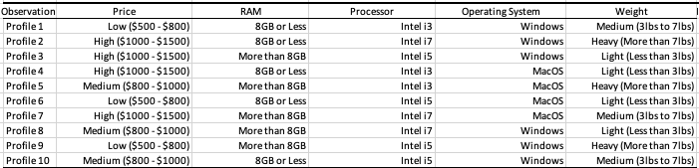

Fig. 4 Ten Profiles generated by Design tool in XLSTAT

The respondents consisted of USF students, USF employees, and some residents. Out of the 120 respondents, 61% (73) are male, and 39% (47) are female. Most of them are employed part time, all of them are between the age of 16 to 56 years, and all of them owned laptops.

**CONJOINT ANALYSIS**

We ran the conjoint analysis from the XLSTAT. The “Utilities (Descriptive Statistics)” table is included below.

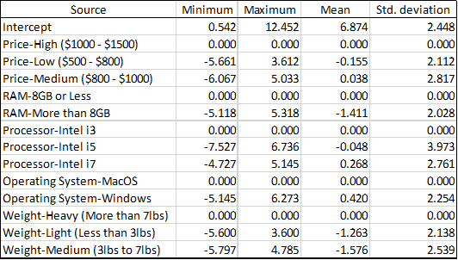

Fig. 5 Utilities (Descriptive Statistics)

The above descriptive statistics indicate that customers preferred **Medium** cost laptops, then High cost. Low-cost laptops were least preferred. This could mean that people were ready to spend on laptops if it has good configurations and features. Laptops with **8GB or less RAM** were more preferred than More than 8GB RAM. Customers preferred **the Intel i7 processor** the most, followed by Intel i3. Intel i5 was the least preferred processor. Customers also preferred the **Windows** operating system, compared to MacOS. Customers preferred **Light** and Medium weight laptops compared to Heavy weighted for obvious reasons. These inferences were derived by observing the mean of the features from the above table.

Below is the preferred profile by the customers according to our analysis:

* Medium cost ($800-$1000), 8GB or less RAM, i7 processor, Windows OS and Light in weight (Less than 3lbs)

**IMPORTANCE (DESCRIPTIVE STATISTICS)**

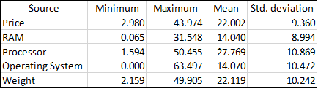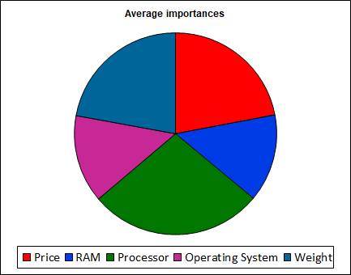

Fig. 6 Importance (Descriptive Statistics)

The above Importance table and Pie-chart shows that all the features were almost equally important to the customers when buying a laptop. However, the **Processor** has slightly more importance than the rest of the four features, followed by the Price and Weight of the laptop. The least important features are RAM and Operating Systems. This inference is derived by observing the mean values of the Importance table added above.

**MARKET GENERATOR AND MARKET SIMULATION**

To generate a new product and predict its market share in comparison with already available products, we used the “Market generator” and “Conjoint analysis simulator tool” option within Conjoint Analysis. We decided to compare the new product with two random profiles from the ten profiles. Next, for the new product, we performed market generator and market simulation twice with two different configurations of the new product (laptop). We will describe these in two different cases.

**CASE 1**: In this case, we came up with a profile that was not present in 10 profiles, the Product 3. No particular logic or reasoning was used to come up with the configuration of this laptop.

The features of all the 3 profiles are in the table below.

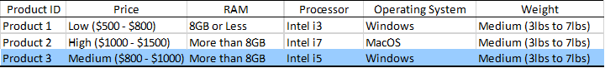

Fig. 7 Market Generator - Case1

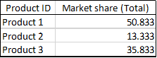

Fig. 8 Market Share using Market Simulator - Case1

The above table indicates the percentage of market share each product will have when all three are present in the market at the same time. Product 1 & 2 are already available in the market and Product 3 will be introduced later. We see through Market Simulator tool of Conjoint Analysis that the Market share of our new product will only gain **35.8%** based on the survey results of the 120 respondents.

**Case 2**: In this case, we came up with a profile not present in the 10 profiles but used the results from the Importance table of Conjoint analysis to decide the configuration of the laptop. As mentioned earlier, according to our analysis, a preferred profile by the customers would be

“Medium cost ($800-$1000), 8GB or less RAM, i7 processor, Windows OS and Light in weight (Less than 3lbs)”. So, we used this configuration in the Product 3. Product 1 and 2 were the same as in Case1.

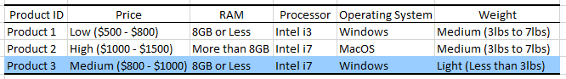

Fig. 9 Market Generator - Case2

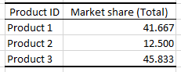

Fig. 10 Market Share using Market Simulator - Case2

In this case, we see that the Market share of our new product will gain **45.83%** based on the survey results of the 120 respondents. It now has the largest market share among the three products. From the results of Case 1 and Case 2 in our analysis, we see that the market share for a new product is significantly more if we consider the results of Importance table in designing our new product. In conclusion, it can be said that Conjoint analysis on the right data together with market generator and market simulator can prove critical in making decisions when introducing a new product in the market.